English as an Additional Language helpful links

Please find attached QR codes for useful applications and web links to aid completion of the admissions form.

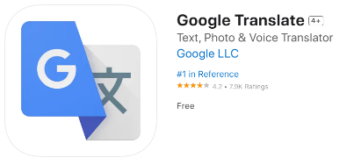Translator applications



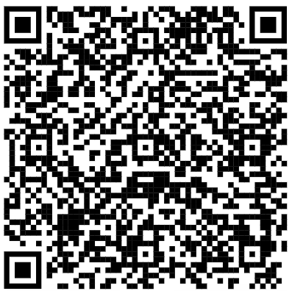 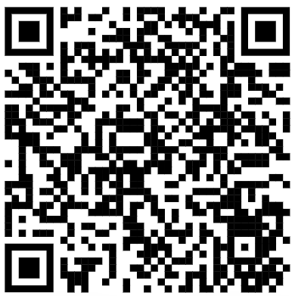

Parent pay Class Dojo

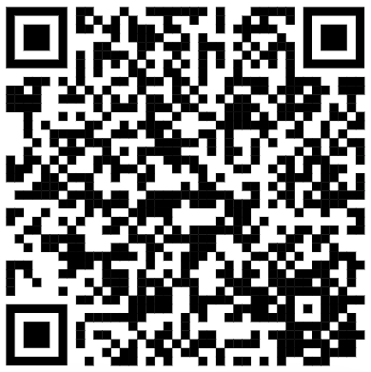 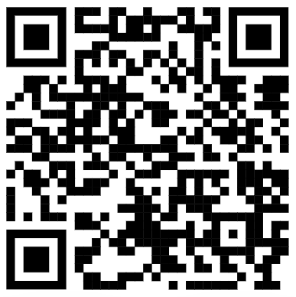

Parent mail Translations on the School Website

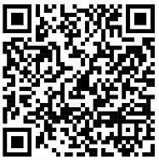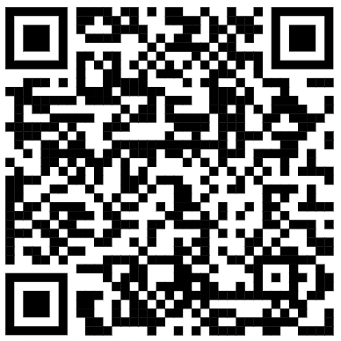

For further support please do not hesitate to contact the school office on

Tel: 01623 465705

Email: admin@priestsic.notts.sch.uk